**Screenshots of Pages**

**Team Number 35**

|  |  |
| --- | --- |
| Student Number | Team Member Name |
| N9718214 | Malcolm Dipple |
| N8604568 | Kainoa Kereama |
| N8578800 | Daniel de Waard |
| N9294317 | Samuel Grice |
| N8910782 | Edward ah Kee |

Tutor: Benjamin Saljooghi, 5pm Thursday.

Version: 1.

Date: 07/06/2017.

The following screenshots are user profiles that are currently not associated with an account. These profiles exist within the website, but cannot be accessed due to difficulties in managing UserRoles, ASP.net’s default account system. The code for each profile page can be found inside the Views/Profile folder.

Property Owner

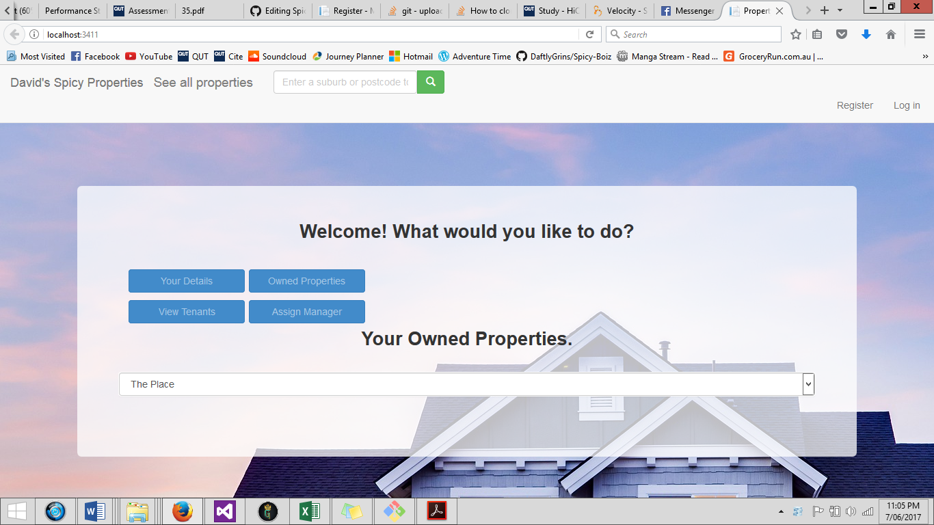

Staff

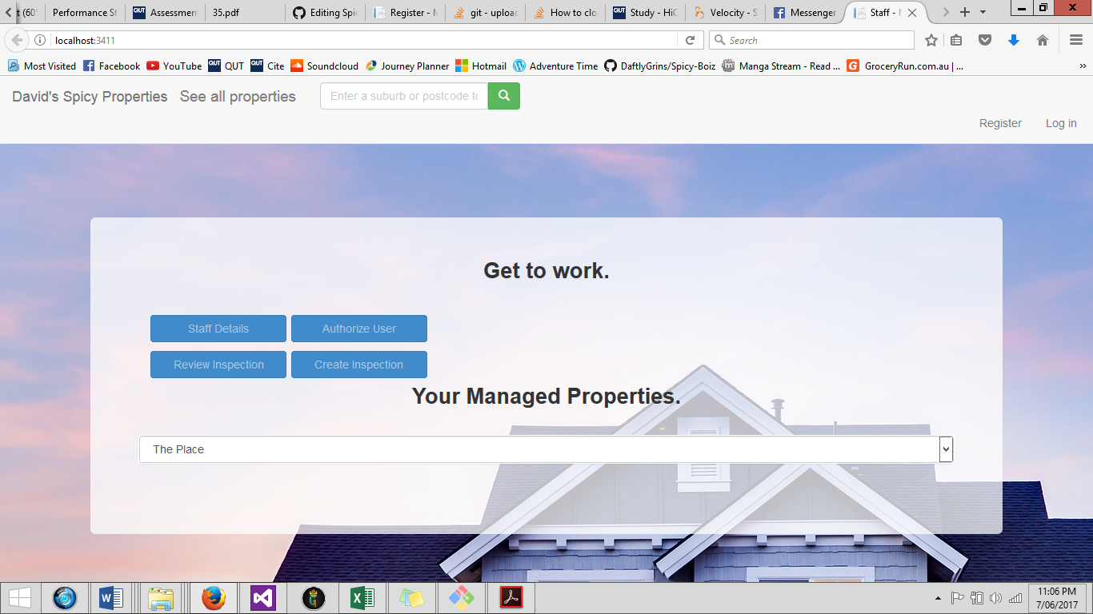

Tenant

